🌐 How to Link the Static Library (.a) to an Atmel Studio 7.0 Project
The LCD panel static graphic libraries (.a) are located within the KVB_LCD project folder, alongside the GUI and evaluation files (.c and .h).
📂 File Structure Overview
- KVB_LCD.h – Main GUI (Graphical User Interface) header file.
- KVB_TEST.h – Header file containing two evaluation/presentation functions tailored for different screen resolutions.
- KVB_TEST.c – Source file implementing the two resolution-dependent evaluation functions.
- KVB_TEXT.h – Header file dedicated to the text variables used in the evaluation code.
- KVB_TEXT.c – Source file containing the text variable definitions for the evaluation code.
- libKVB_LCD_16bit_ATmega128_9325.a – Static library file for the ILI9325 LCD panel (320 x 240 resolution).
- libKVB_LCD_16bit_ATmega128_9341.a – Static library file for the ILI9341 LCD panel (320 x 240 resolution).
- libKVB_LCD_16bit_ATmega128_9481.a – Static library file for the ILI9481 LCD panel (480 x 320 resolution).
- libKVB_LCD_16bit_ATmega128_9486.a – Static library file for the ILI9486 LCD panel (480 x 320 resolution).
- libKVB_LCD_16bit_ATmega128_8009A.a – Static library file for the OTM8009A LCD panel (800 x 480 resolution).

⚙️ Linker Configuration Steps
- Open the target project's Properties by pressing Alt + F7.
- Navigate to Toolchain -> AVR/GNU Linker -> Libraries.
- In the upper window (Libraries (-Wl,-l)), click the + (Add Item) button and type the name of your library strictly WITHOUT the lib prefix and WITHOUT the .a extension. For instance, if your file is named libKVB_LCD_16bit_ATmega128_9481.a, enter exactly: KVB_LCD_16bit_ATmega128_9481. Note: Only one graphic library must be added to the project configuration at a time.
- In the lower window (Library search path (-L)), click the + (Add Item) button and specify the directory path where your physical library file (e.g., libKVB_LCD_16bit_ATmega128_9481.a) is located.
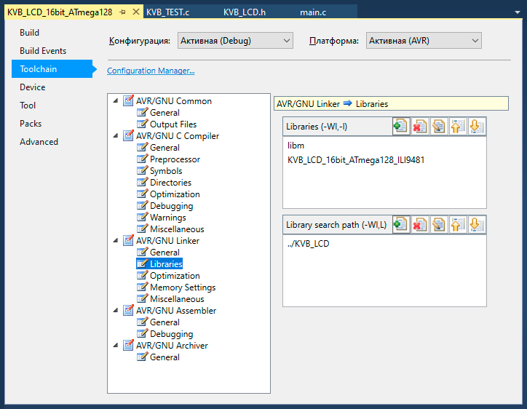
During the build process, Atmel Studio 7.0 will automatically fetch and link the pre-compiled binary code from your specified library file (e.g., libKVB_LCD_16bit_ATmega128_9481.a).

- Finally, navigate to your project's main.c file and uncomment one of the two evaluation functions depending on your display's resolution: lcd_Test480x320Landscape() or lcd_Test320x240Landscape().

